## PROGRAM DEFINITION

|  |
| --- |
|  |
| * Program untuk mencetak report untuk schedule dan checklistnya terkait handover |

## RELATED TABLES

|  |  |
| --- | --- |
|  | **Access** |
| * PMT_AGREEMENT * PMT_AGREEMENT_UNIT * PMM_TENANT * PMM_STAFF * PMM_HANDOVER_CHECKLIST | * R * R |

## ROLES

|  |  |
| --- | --- |
|  | **Test** |
| * User yg mempunyai akses ke program |  |

## INITIAL PROCESS

|  |  |
| --- | --- |
|  | **Test** |
| * Set VAR_COMPANY_ID = Login User’s Company ID * Set VAR_USER_ID = Login User ID * Set VAR_LANGUAGE_ID = Login User’s Language ID * Jalankan RSP_GS_GET_PROPERTY_LIST dengan parameter, simpan hasil ke VAR_SELECTED_PROPERTY   + VAR_COMPANY_ID   + VAR_LANGUAGE_ID * Jalankan RSP_GS_GET_PERIOD_YEAR_RANGE dengan parameter, simpan hasil ke VAR_PERIOD_YEAR   + VAR_COMPANY_ID   + ‘’   + ‘’ * Set VAR_PERIOD_MONTH_LIST (as array of object) with VAR_MONTH_NUMBER and VAR_MONTH_NAME.   + Set VAR_MONTH_CODE = 01, 02, …, 12   + Set VAR_MONTH_NAME = January, February, …, December * Set VAR_REPORT_TYPE (as array of object) with VAR_REPORT_CODE and VAR_REPORT_DESCRIPTION.   + Set VAR_REPORT_CODE = ‘S’, ‘D’   + Set VAR_REPORT_NAME = Summary, Detail * Set VAR_TYPE (as array of object) with VAR_CODE and VAR_DESCRIPTION. **[CR01]**   + Set VAR_CODE = ‘S’, ‘O’, ‘L’   + Set VAR_NAME = Strata, Owner, Lease |  |

## TAB HANDOVER REPORT

### USER INTERFACE

#### CR01

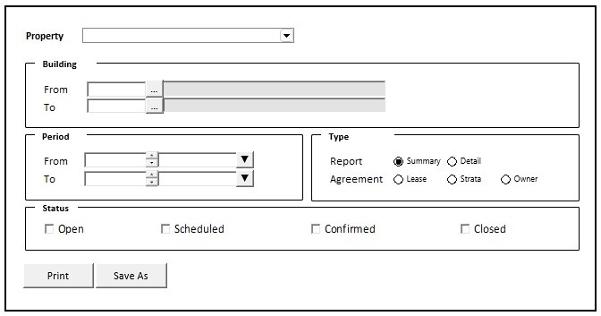

#### INITIAL VERSION

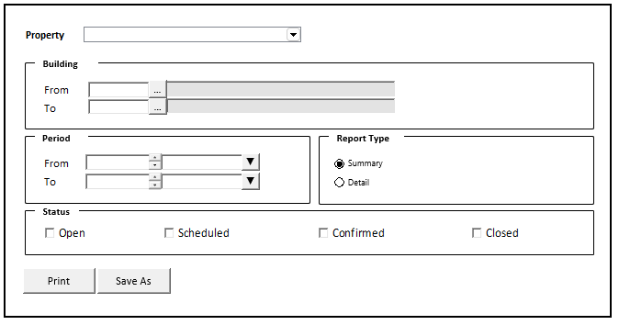

### TAB DEFINITION

|  |  |  |
| --- | --- | --- |
| **Tab Name** | **Action** | **Enabled** |
|  |  |  |
|  |  |  |

### BUTTON DEFINITION

|  |  |  |
| --- | --- | --- |
| **Button Name** | **Action** | **Enabled** |
| Print | Jalankan PRINT PROCESS |  |
| Save As | Jalankan PRINT PROCESS |  |

### ROLES

|  |  |
| --- | --- |
|  | **Test** |
| * User yg punya akses ke program |  |

### INITIAL PROCESS

|  |  |
| --- | --- |
|  | **Test** |
|  |  |

### DISPLAY PROCESS

#### FIELD DEFINITION

|  |  |  |  |
| --- | --- | --- | --- |
| **Name** | **Field** | **Type** | **Validation** |
| Property | CPROPERTY_ID | Combobox  Isi combobox dengan RSP_GS_GET_PROPERTY_LIST dengan parameter   * VAR_COMPANY_ID * VAR_USER_ID   Set ValueField = CPROPERTY_ID  Set TextField = CPROPERTY_NAME  Simpan hasil ke VAR_SELECTED_PROPERTY | On Value Changed,  Set VAR_SELECTED_PROPERTY = Selected Combobox’s Value |
| Building From | CFROM_BUILDING_ID | Textbox | On Lost Focus  Go to 🡪 BUILDING LOOKUP PROCESS  On value change, update:  CFROM_BUILDING_ID, CFROM_BUILDING_NAME |
|  |  | Lookup | On Lookup Button clicked:  Go to 🡪 BUILDING LOOKUP PROCESS  On value change, update:  CFROM_BUILDING_ID, CFORM_BUILDING_NAME |
|  | CFROM_BUILDING_NAME | Textbox, Disabled |  |
| Building To | CTO_BUILDING_ID | Textbox | On Lost Focus  Go to 🡪 BUILDING LOOKUP PROCESS  On value change, update:  CTO_BUILDING_ID, CTO_BUILDING_NAME |
|  |  | Lookup | On Lookup Button clicked:  Go to 🡪 BUILDING LOOKUP PROCESS  On value change, update:  CTO_BUILDING_ID, CTO_BUILDING_NAME |
|  | CTO_BUILDING_NAME | Textbox, Disabled |  |
| Period From | IFROM_PERIOD_YEAR | NumericTextbox  Set Default NumericTextbox value: NOW.YEAR | Decimal Places = 0  MinValue = VAR_PERIOD_YEAR.IMIN_YEAR  MaxValue = VAR_PERIOD_YEAR.IMAX_YEAR |
|  | IFROM_PERIOD_MONTH | Combobox  Isi combobox dengan VAR_PERIOD_MONTH_LIST  Set ValueField = VAR_MONTH_CODE  Set TextField = VAR_MONTH_NAME  Set Default Combobox Value = NOW.MONTH | Decimal Places = 0 |
| Period To | ITO_PERIOD_YEAR | NumericTextbox  Set Default NumericTextbox value: NOW.YEAR | Decimal Places = 0  MinValue = VAR_PERIOD_YEAR.IMIN_YEAR  MaxValue = VAR_PERIOD_YEAR.IMAX_YEAR |
|  | ITO_PERIOD_MONTH | Combobox  Isi combobox dengan VAR_PERIOD_MONTH_LIST  Set ValueField = VAR_MONTH_CODE  Set TextField = VAR_MONTH_NAME  Set Default Combobox Value = NOW.MONTH | Decimal Places = 0 |
| Report Type | CREPORT_TYPE | RadioButton  Isi radiobutton dengan VAR_REPORT_TYPE  Set ValueField = VAR_REPORT_CODE  Set TextField = VAR_REPORT_NAME  Set Default Radiobutton Value = ‘S’ |  |
| Agreement Type  **[CR01]** | CTYPE | RadioButton  Isi radiobutton dengan VAR_TYPE  Set ValueField = VAR_CODE  Set TextField = VAR_NAME  Set Default Radiobutton Value = ‘S’ |  |
| Status | LOPEN  Display: Open | Checkbox | Default Value = Unchecked |
|  | LSCHEDULED  Display: Scheduled | Checkbox | Default Value = Unchecked |
|  | LCONFIRMED  Display: Confirmed | Checkbox | Default Value = Unchecked |
|  | LCLOSED  Display: Closed | Checkbox | Default Value = Unchecked |

### BUILDING LOOKUP PROCESS

#### ON LOST FOCUS

##### PARAMETER

|  |  |
| --- | --- |
| **Parameter Name** | **Description** |
| CCOMPANY_ID | VAR_COMPANY_ID |
| CPROPERTY_ID | VAR_SELECTED_PROPERTY.CPROPERTY_ID |
| CUSER_ID | VAR_USER_ID |
| CSEARCH_TEXT | Building Id field’s value |

##### ACTION

|  |
| --- |
|  |
| * Run **GSL02200 – Building Lookup** dengan parameter:   + CCOMPANY_ID   + CPROPERTY_ID   + CUSER_ID   + CSEARCH_TEXT * Set Display Process   IF from **Building From Id** field  CFROM_BUILDING_ID = LOOKUP_RETURN_VALUE.CBUILDING_ID  CFROM_BUILDING_NAME = LOOKUP_RETURN_VALUE.CBUILDING_NAME  IF from **Building To Id** field  CTO_BUILDING_ID = LOOKUP_RETURN_VALUE.CBUILDING_ID  CTO_BUILDING_NAME = LOOKUP_RETURN_VALUE.CBUILDING_NAME |
|  |

#### BEFORE OPEN LOOKUP

##### PARAMETER

|  |  |
| --- | --- |
| **Parameter Name** | **Description** |
| CCOMPANY_ID | VAR_COMPANY_ID |
| CPROPERTY_ID | VAR_SELECTED_PROPERTY.CPROPERTY_ID |
| CUSER_ID | VAR_USER_ID |

##### ACTION

|  |
| --- |
|  |
| * Run **GSL02200 – Building Lookup** dengan parameter:   + CCOMPANY_ID   + CPROPERTY_ID   + CUSER_ID |
|  |

#### AFTER OPEN LOOKUP

##### CANCEL PROCESS

###### ACTION

|  |
| --- |
|  |
| * Close this POPUP |
|  |

##### LOOKUP SELECT DATA PROCESS

###### ACTION

|  |
| --- |
|  |
| * Close lookup * Set Display Process   IF from **Building From Id** field  CFROM_BUILDING_ID = LOOKUP_RETURN_VALUE.CBUILDING_ID  CFROM_BUILDING_NAME = LOOKUP_RETURN_VALUE.CBUILDING_NAME  IF from **Building To Id** field  CTO_BUILDING_ID = LOOKUP_RETURN_VALUE.CBUILDING_ID  CTO_BUILDING_NAME = LOOKUP_RETURN_VALUE.CBUILDING_NAME |
|  |

### PRINT PROCESS

#### REPORT LAYOUT

PAPER SIZE: A4 LANDSCAPE  
REPORT TYPE: SUMMARY

##### [CR01]

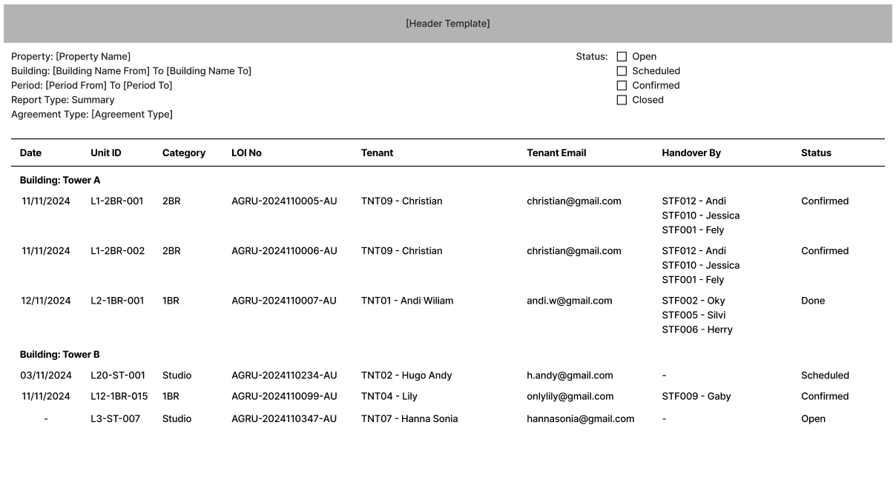

##### INITIAL VERSION

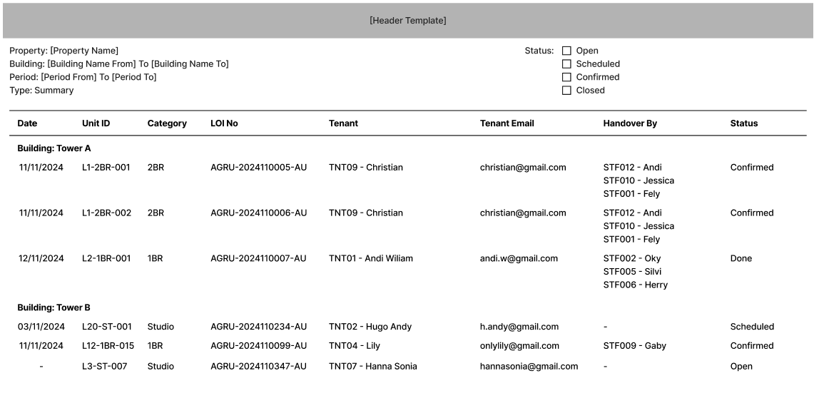

PAPER SIZE: A4 LANDSCAPE  
REPORT TYPE: DETAIL

##### [CR01]

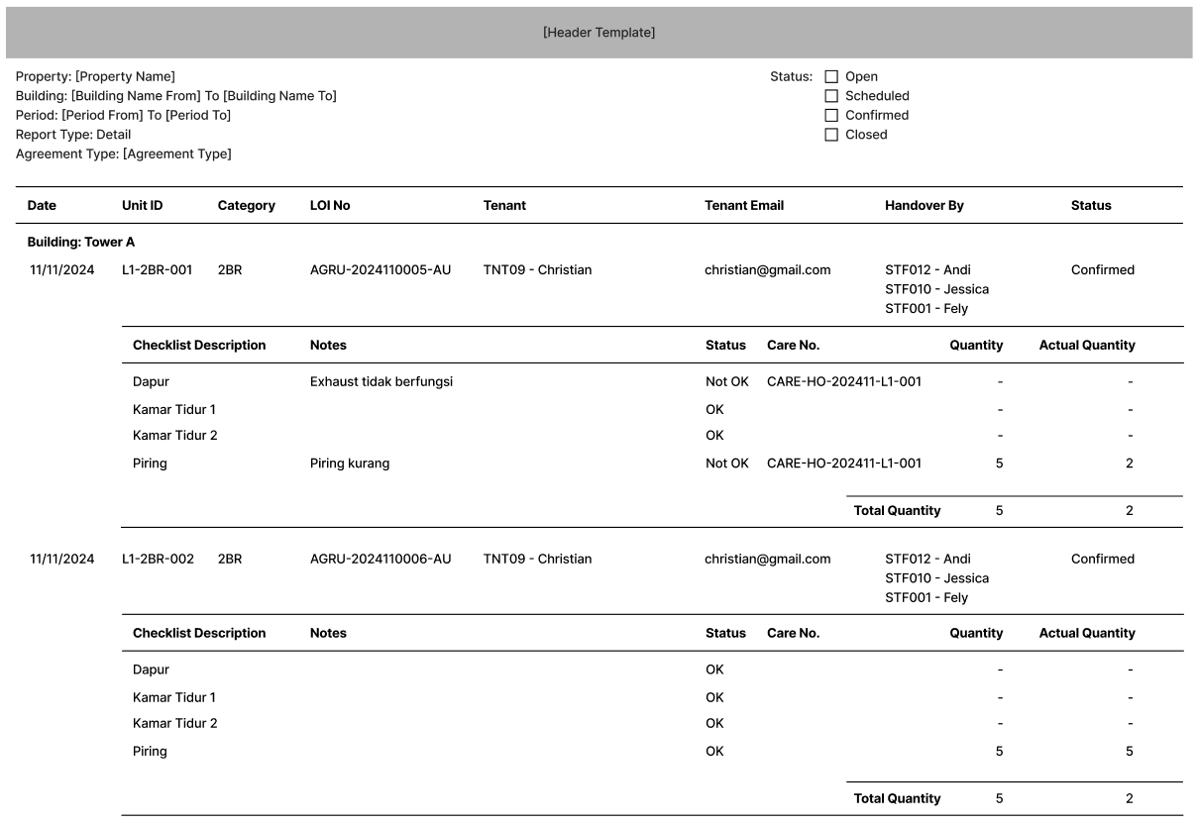

##### INITIAL VERSION

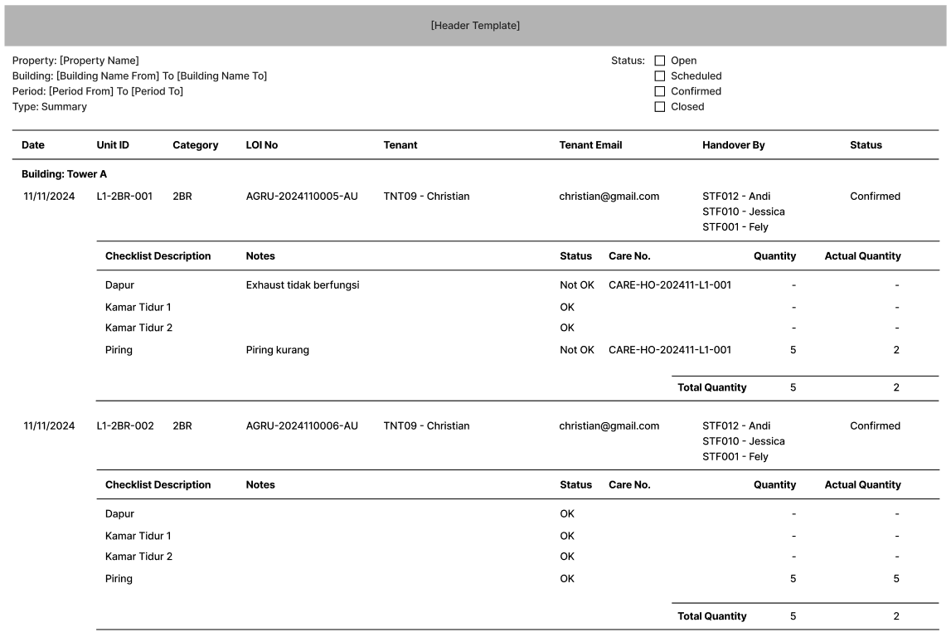

#### REPORT DEFINITION

|  |  |  |  |
| --- | --- | --- | --- |
| **Section** | **Name** | **Field** | **Validation** |
| HEADER | Property | VAR_SELECTED_PROPERTY | Format: “Property Name”  Ex. “Harco Mas” |
|  | Building | CFROM_BUILDING_NAME  CTO_BUILDING_NAME | IF CTO_BUILDING_ID <> NULL and CTO_BUILDING_ID <> CFROM_BUILDING_ID  Format: “Building Name From To Building Name To”  ELSE  Format: “Building Name From”  Ex. 1  Selected From: TW-1 – Tower A  Selected To: TW-2 – Tower B  Display: “Tower A to Tower B”  Ex.2  Selected From: TW-1 – Tower A  Selected To: ‘’  Display: “Tower A” |
|  | Period | CFROM_PERIOD **(MMM yyyy)** = CFROM_PERIOD_YEAR,  CFROM_PERIOD_MONTH  CTO_PERIOD **(MMM yyyy)** = CTO_PERIOD_YEAR, CTO_PERIOD_MONTH | IF CTO_PERIOD <> CFROM_PERIOD  Format: “Period From to Period To”  ELSE  Format: “Period”  Ex.1  Selected From: “202403”  Selected To: “202404”  Display: “March 2024 To April 2024”  Ex.2  Selected Form: “202403”  Selected To: “202403”  Display: “March 2024” |
|  | Report Type  **[CR01]** | CREPORT_TYPE | Format: “Report Type’s Name”  Display: “Summary” |
|  | Agreement Type  **[CR01]** | CTYPE | Format: “Agreement Type’s Name”  Display: “Strata” |
|  | Status | LOPEN  LSCHEDULED  LCONFIRMED  LCLOSED | IF Status = TRUE, then show checkbox with checked value  Else, show checkbox with unchecked value |
|  |  |  |  |
| REPORT GROUP | Company | CCOMPANY_ID | Hidden |
| Property | CPROPERTY_ID | Hidden |
| Building | CBUILDING_ID | “Building: CBUILDING_NAME” |
| GROUP BY LOI | Date | CSCHEDULE_DATE | Format: “dd/mm/yyyy” |
| Unit ID | CUNIT_ID |  |
| Category | CUNIT_TYPE_CATEGORY |  |
| LOI No | CREF_NO |  |
| Tenant | CTENANT_ID | “CTENANT_ID – CTENANT_NAME” |
| Tenant Email | CTENANT_EMAIL |  |
| Status | CHANDOVER_STATUS |  |
| GROUP BY LCHECKLIST = 0 | Handover By | CSTAFF_ID | “CSTAFF_ID – CSTAFF_NAME”  If CSTAFF_ID is NULL or EMPTY, then “-“ |
| GROUP BY LCHECKLIST = 1 | Checklist Description | CCHECKLIST_DESCRIPTION |  |
| Notes | CNOTES | If CNOTES is NULL or EMPTY, then “” |
| Status | LCHECKLIST_STATUS | If LCHECKLIST_STATUS = TRUE, then “OK”  Else, “Not OK” |
| Care No. | CCARE_REF_NO | If CCARE_REF_NO is NULL or EMPTY , then “” |
| Quantity | IDEFAULT_QUANTITY | If IDEFAULT_QUANTITY is 0, then “-“ |
| Actual Quantity | IACTUAL_QUANTITY | If IDEFAULT_QUANTITY is not 0, then  IACTUAL_QUANTITY  Else, “-“ |
| Summarize | Total Quantity |  | Sum of each IDEFAULT_QUANTITY |
| Sum of each IACTUAL_QUANTITY |

#### VALIDATION

|  |  |  |
| --- | --- | --- |
| **Field** | **Condition** | **Validation Message** |
| Property | Empty | Please select Property! |
| Building From | Empty | Please select Building From! |
| Building To | Empty | Please select Building To! |
| Period From | Empty | Please fill Period From! |
| Period To | Empty | Please fill Period To! |
| Period From, Period To | If Period From > Period To | Period From cannot be after Period To! |
| Status | All is unchecked | Please check at least one status! |

#### ACTION

|  |
| --- |
|  |
| * **Validate** (See VALIDATION table)   IF Success, jalankan **Get Report Data**   * **Get Report Data**   Jalankan RSP_PMR00460_GET_REPORT dengan parameter,  @CCOMPANY_ID = VAR_COMPANY_ID  @CPROPERTY_ID = VAR_SELECTED_PROPERTY.CPROPERTY_ID  @CFROM_BUILDING_ID = ‘Building From ID’s field’  @CTO_BUILDING_ID = ‘Building To ID’s field’  @CFROM_PERIOD = ‘Period From Year and Month’ (YYYYMM)  @CTO_PERIOD = ‘Period To Year and Month’ (YYYYMM)  @CREPORT_TYPE = ‘Report Type’s value’ (S/D)  @LOPEN = ‘Status Open checkbox’s value’  @LSCHEDULED = ‘Status Scheduled checkbox’s value’  @LCONFIRMED = ‘Status Confirmed checkbox’s value’  @LCLOSED = ‘Status Closed checkbox’s value’  @CLANG_ID = VAR_LANGUAGE_ID  Ex.  EXEC RSP_PMR00460_GET_REPORT  ‘BSI’  , ‘ASHMD’  , ‘TW-1’  , ‘TW-3’  , ‘202410’  , ‘202411’  , ‘D’  , ‘1’  , ‘1’  , ‘1’  , ‘1’  , ‘EN’ |
| * Proses:   + ‘Print’ 🡪 Display Report PDF File in new tab   + ‘Save As 🡪 Prompt download as Excel |

# CR LIST

|  |  |  |
| --- | --- | --- |
| **CR** | **Description** | **Notes** |
| CR01  NS, 16 Des 2024 | * Menambahkan Agreement Type |  |